**(17) Pressure Models**

Pressure conditions:

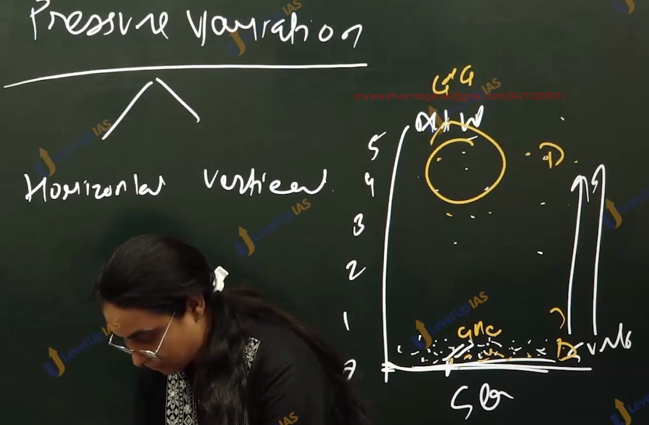

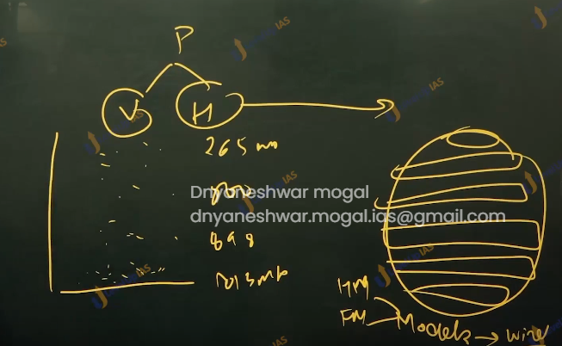

1. There are 7 pressure variations.
2. There are 2 types of pressure variation horizontal, and vertical. Near the sea level there is more atmospheric pressure while the pressure decreases with the increases in height.
3. At zero km (sea level) height the pressure is about 1013 mb at 1 km it about 898 mb at 10 km the pressure is 256 mb.
4. There are also horizontal pressure variations on the surface of the earth which can be understood with the various models.
5. It is important to understand pressure variations as affects the movement of air and winds. pressures that determines whether there would be vertical movement or not.

There

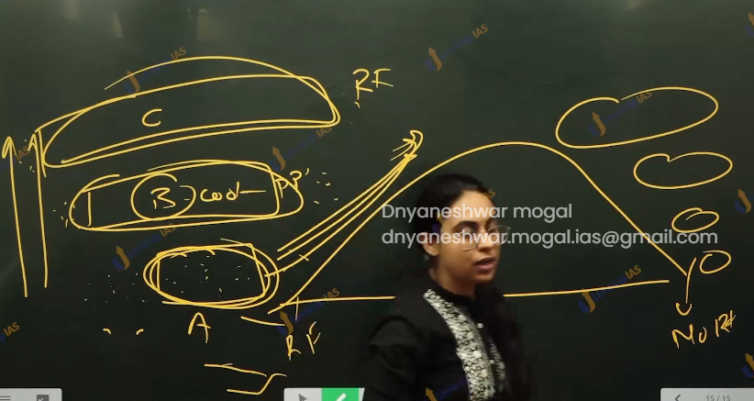

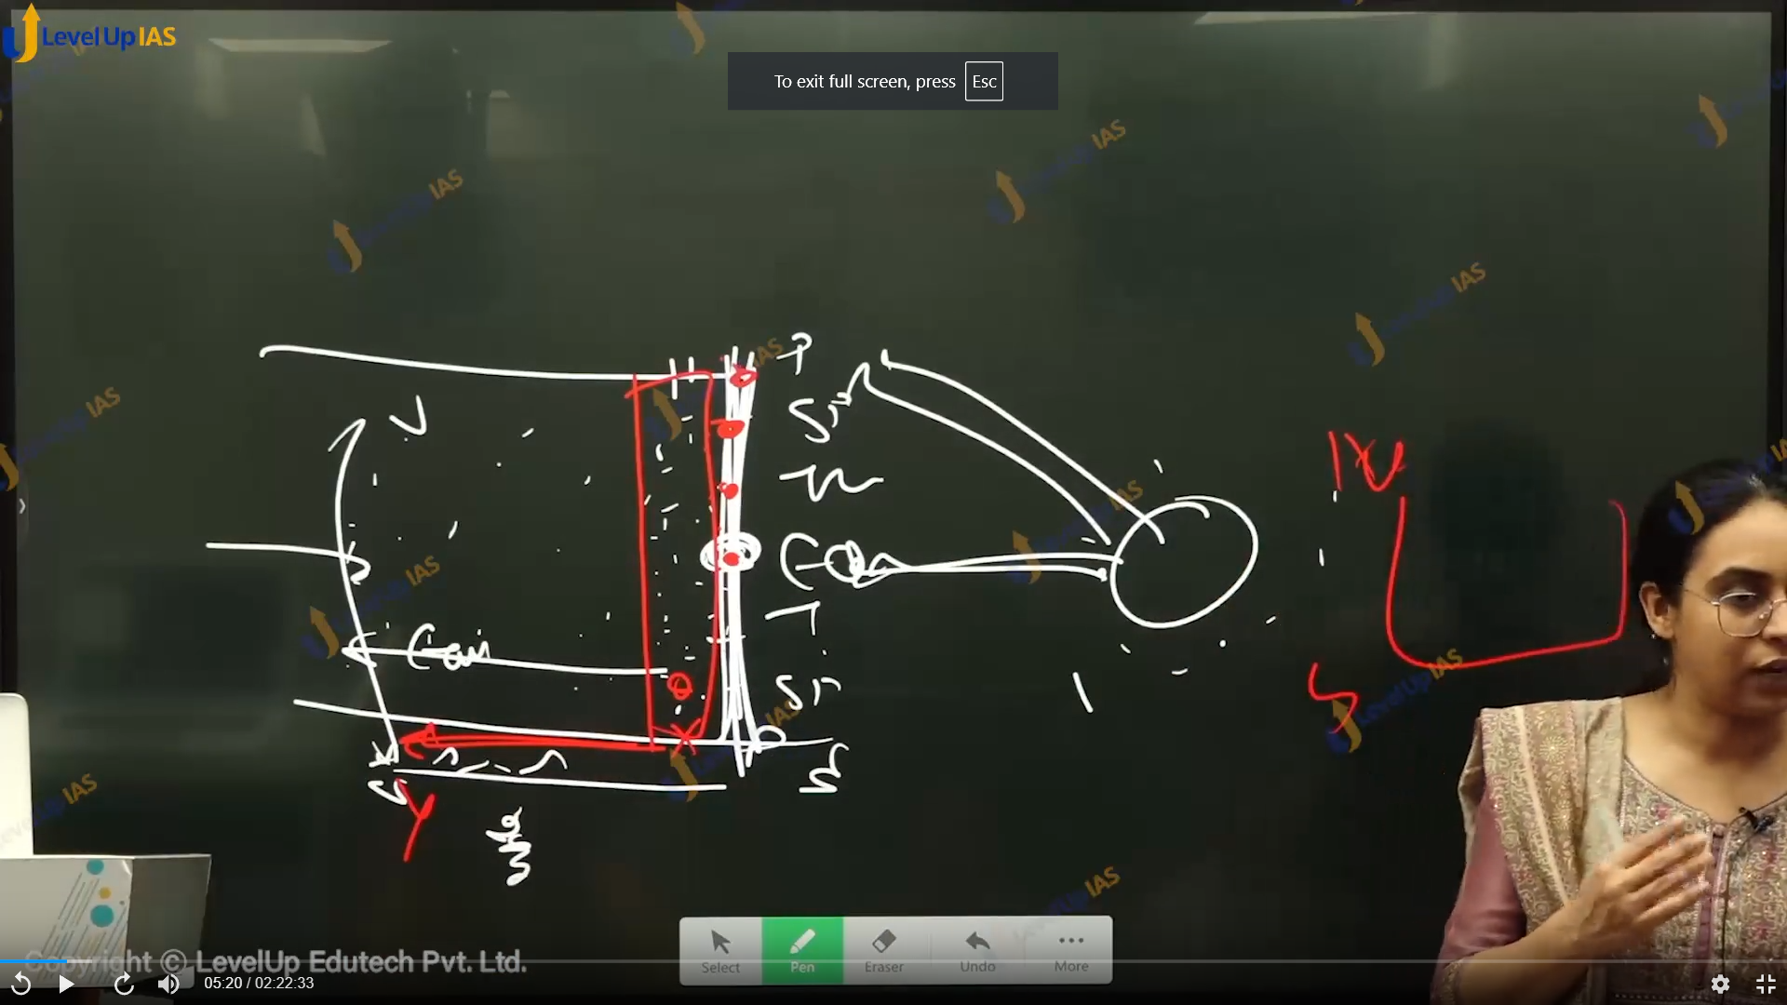

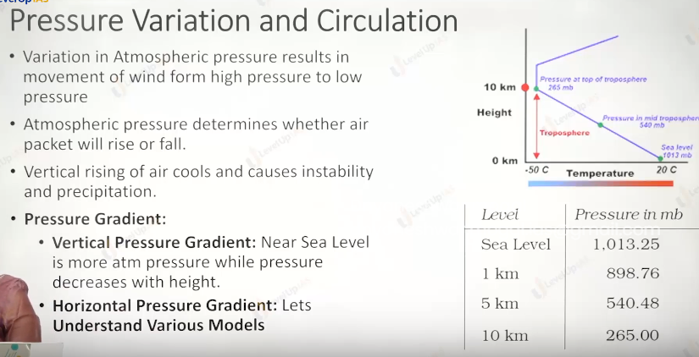

Surface pressure variation.

To understand surface pressure variation certain models have been developed. Models represent the simplification of reality, therefore, to simplify reality there are curtains assumptions. Two famous model are

1. Hadley model / unicellular model.
2. Ferrel’s model (tricellular model).

Hardey’s model:

Hardey involved two assumptions:

1. Homogeneous surface that is no land water differentials
2. Nonrotating earth. Therefore, it does not account for Coriolis force.

Model:

1. The equator is warm, the air above the equator becomes warm and rises up to tropopause. The air after reaching tropopause gets deflected towards the poles. On reaching at the poles the air cools and start sinking. This leads to the air moving from poles to equator. As per hardly there are 3 pressure belts on the surface of earth 1. Equatoria low pressure belt 2. Two polar high-pressure belt and there is one shell per hemisphere therefore, it models called unicellular model.

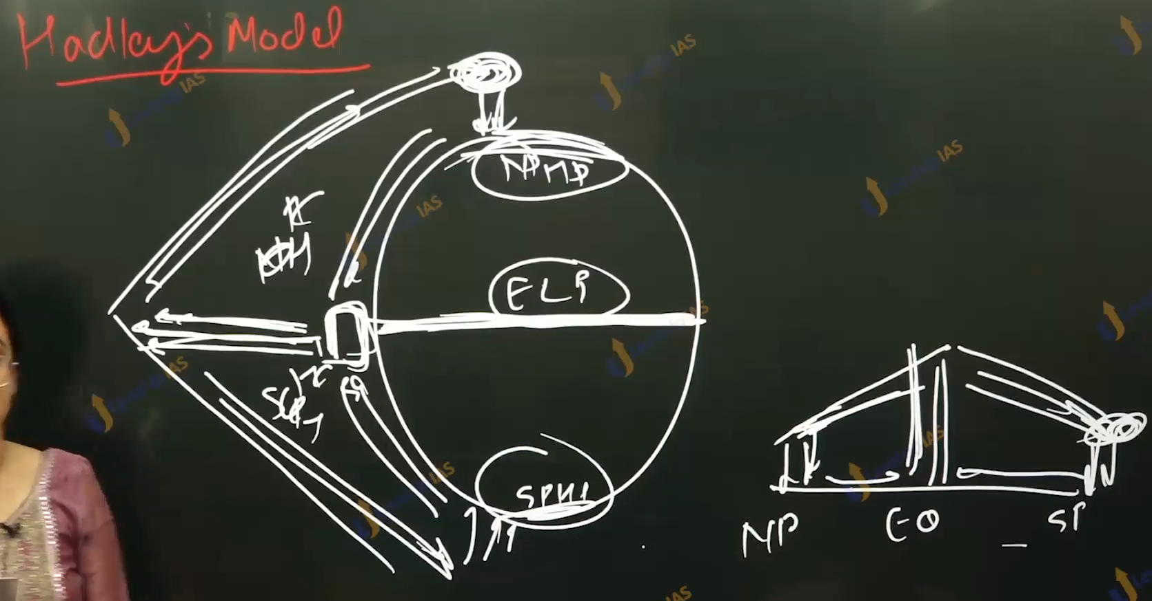

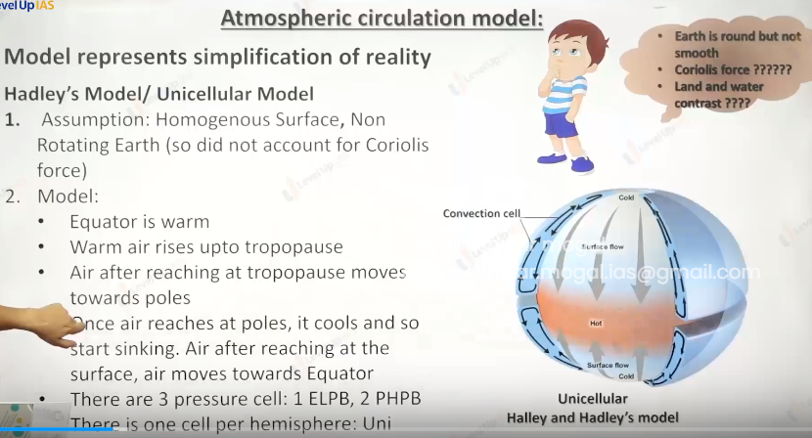

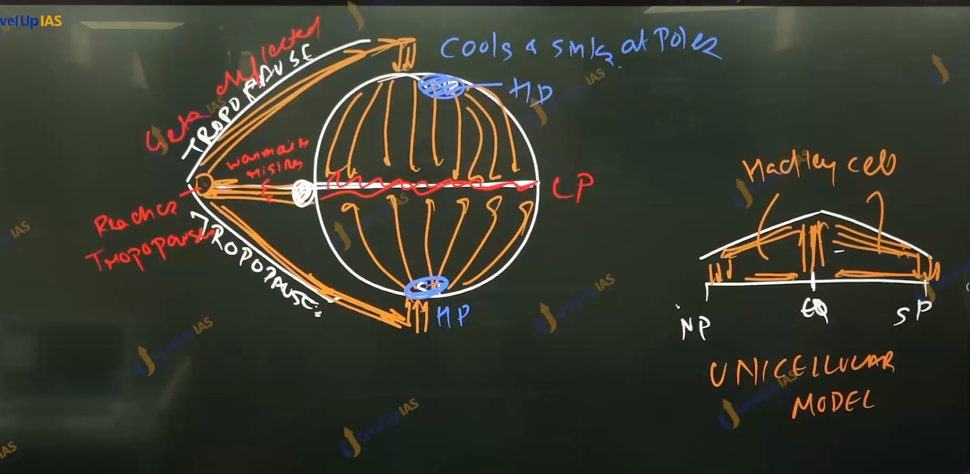

1. Tricellular model:
   1. Assumption:
      1. Homogenous surface and rotating earth (he accounted for Coriolis force
   2. Model
      1. There was a dramatic improvement to Hadley’s model.
      2. Along with insolation the Ferrel accounting for role of Coriolis force
      3. As per this model warm air raises at equator and reaches tropopause and depleted towards the poles
      4. Warms air cools when it reaches the tropopause. Above 30 degrees north or south air sinks
      5. Warms air moves from 30 degrees north from south towards 60 north south and some air packet also moved towards equator.
      6. At 60 north or south there is interaction cooled air from the poles and warms air which has moved from the 30 degrees north or south to wars 60 degree north or south.
      7. Warm air posted to raise up, this air on reaching tropopause gets depleted towards 30 degrees and 90 degrees
      8. At 90 degrees the air cools and it sinks therefore, it models have 3 cell per hemisphere.
      9. As per model there are 7 pressure belts.
         1. Equatorial low-pressure belt.
         2. 2 subtropic high-pressure belt.
         3. 2 subpolar low-pressure belts.
         4. 2 polar high-pressure belts.
   3. Improvements of Ferrel’s model / benefits of Ferrel’s model.
      1. He was able to explain planetary winds like trad winds, wester leaves and polar ester leaves.
      2. Ferrel is better able to explain the rainfall conditions at the subpolar conditions.
      3. Ferrel is better able to explain the formation of desert at subtropic ex, Sahar desert, athames desert, thar desert, great Australian desert etc.
   4. Limitation of Ferrel’s model.
      1. Upper troposphere circulation has not been currently interpreted by the Ferrel. Ferrel considers the upper tropospheric wind to be mirror oppositive of surface wind. Which is not true.
      2. The local and regional circulation has not been explained by Ferrel.
      3. Simplistic assumptions that is land-water contrast. In reality there are pressure cells. Some pressure cells are permanent and some are seasonal pressure cells.

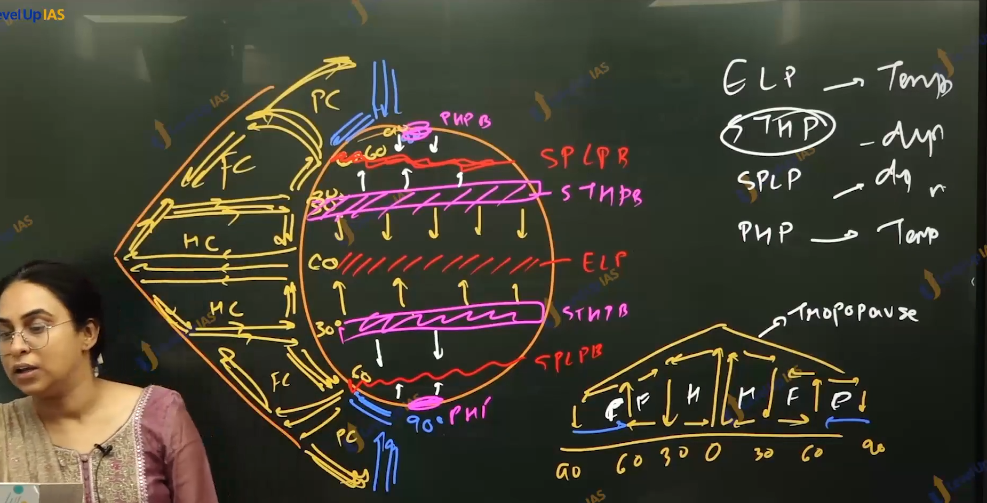

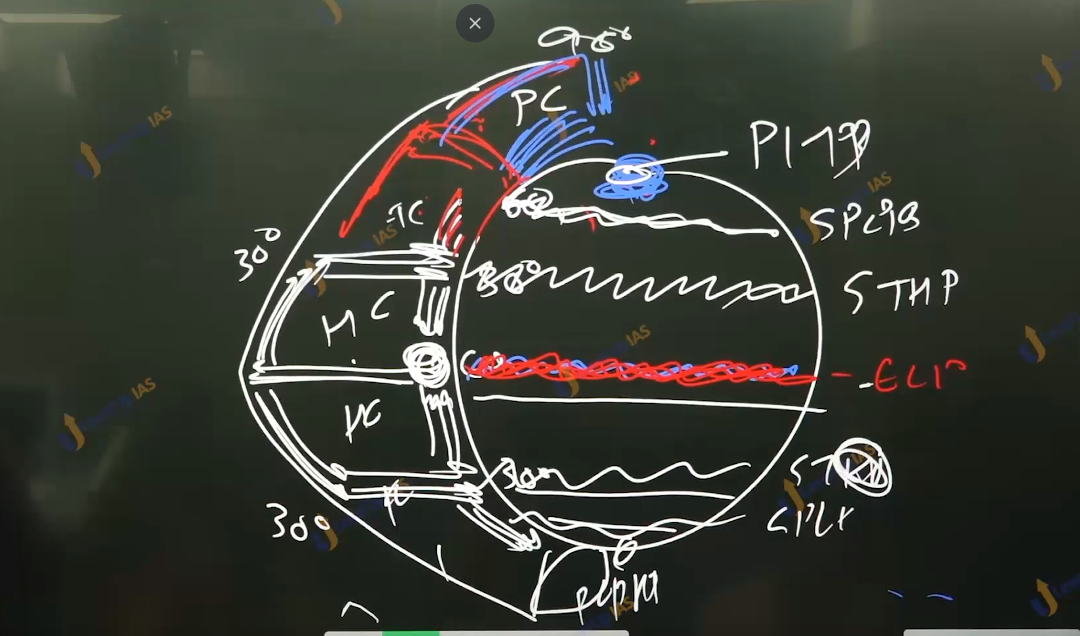

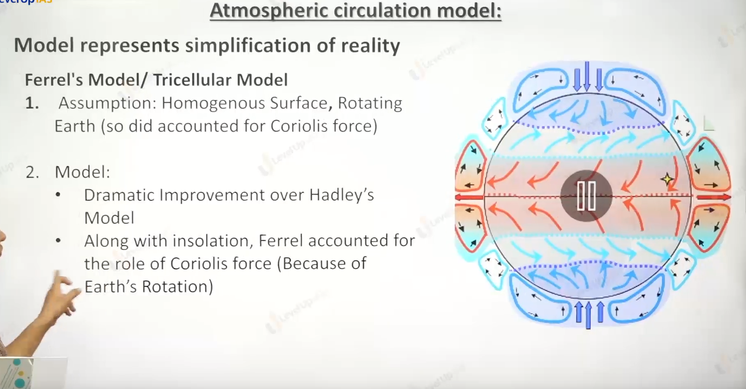

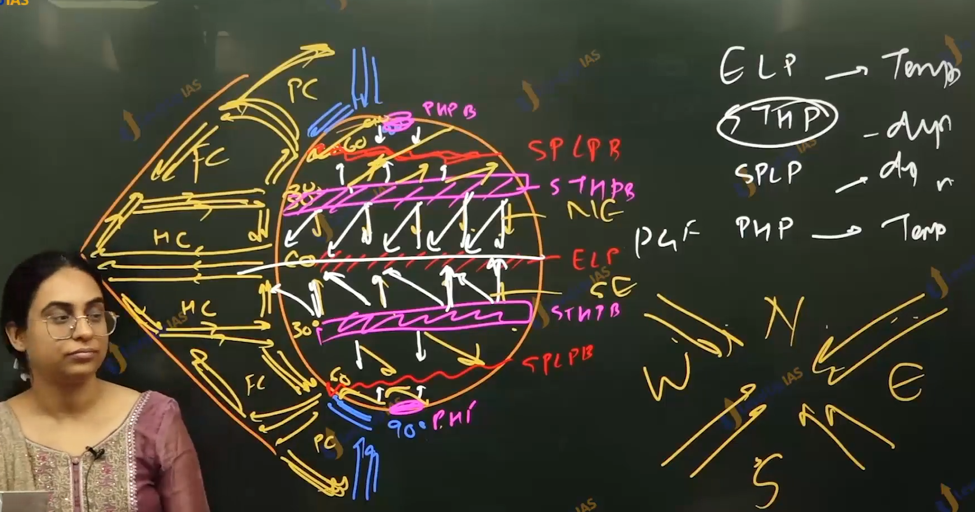

Winds:

1. Winds are horizontal movement of air from high pressure to low pressure.
2. Wind is governed by 3 major forces
   1. Pressure gradient force
   2. Coriolis force
   3. Frictional force.
3. Pressure gradient force:
   1. The difference in atmosphere pressure produces force. Therefore, wind blows from high pressure to low pressure.
   2. When the isobar is closely situated the pressure gradient is higher and wind speed is more.
   3. 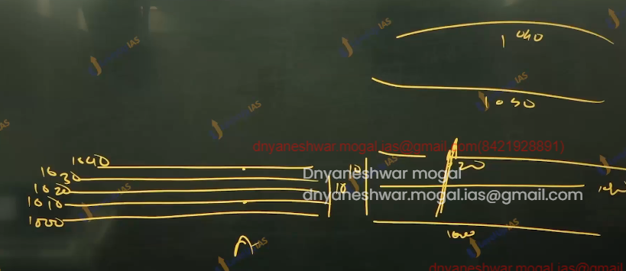
4. Coriolis force:
   1. Rotation of earth affects the direction of winds. This force was detected by French physicist and hence this force is name after him this force is called Coriolis force.
   2. Coriolis force deflects the winds to the right in the northern hemisphere and to left in the southern hemisphere.
   3. Coriolis force is directly proportional to the angle of latitude
   4. Greater the angel there greater is Coriolis force the Coriolis are zero to the equator and maximum at poles
   5. The deflection is more when the velocity is more. higher PGF more is the velocity of wind, more is the Coriolis force the more deflection (seen in the case of upper tropospheric winds.)

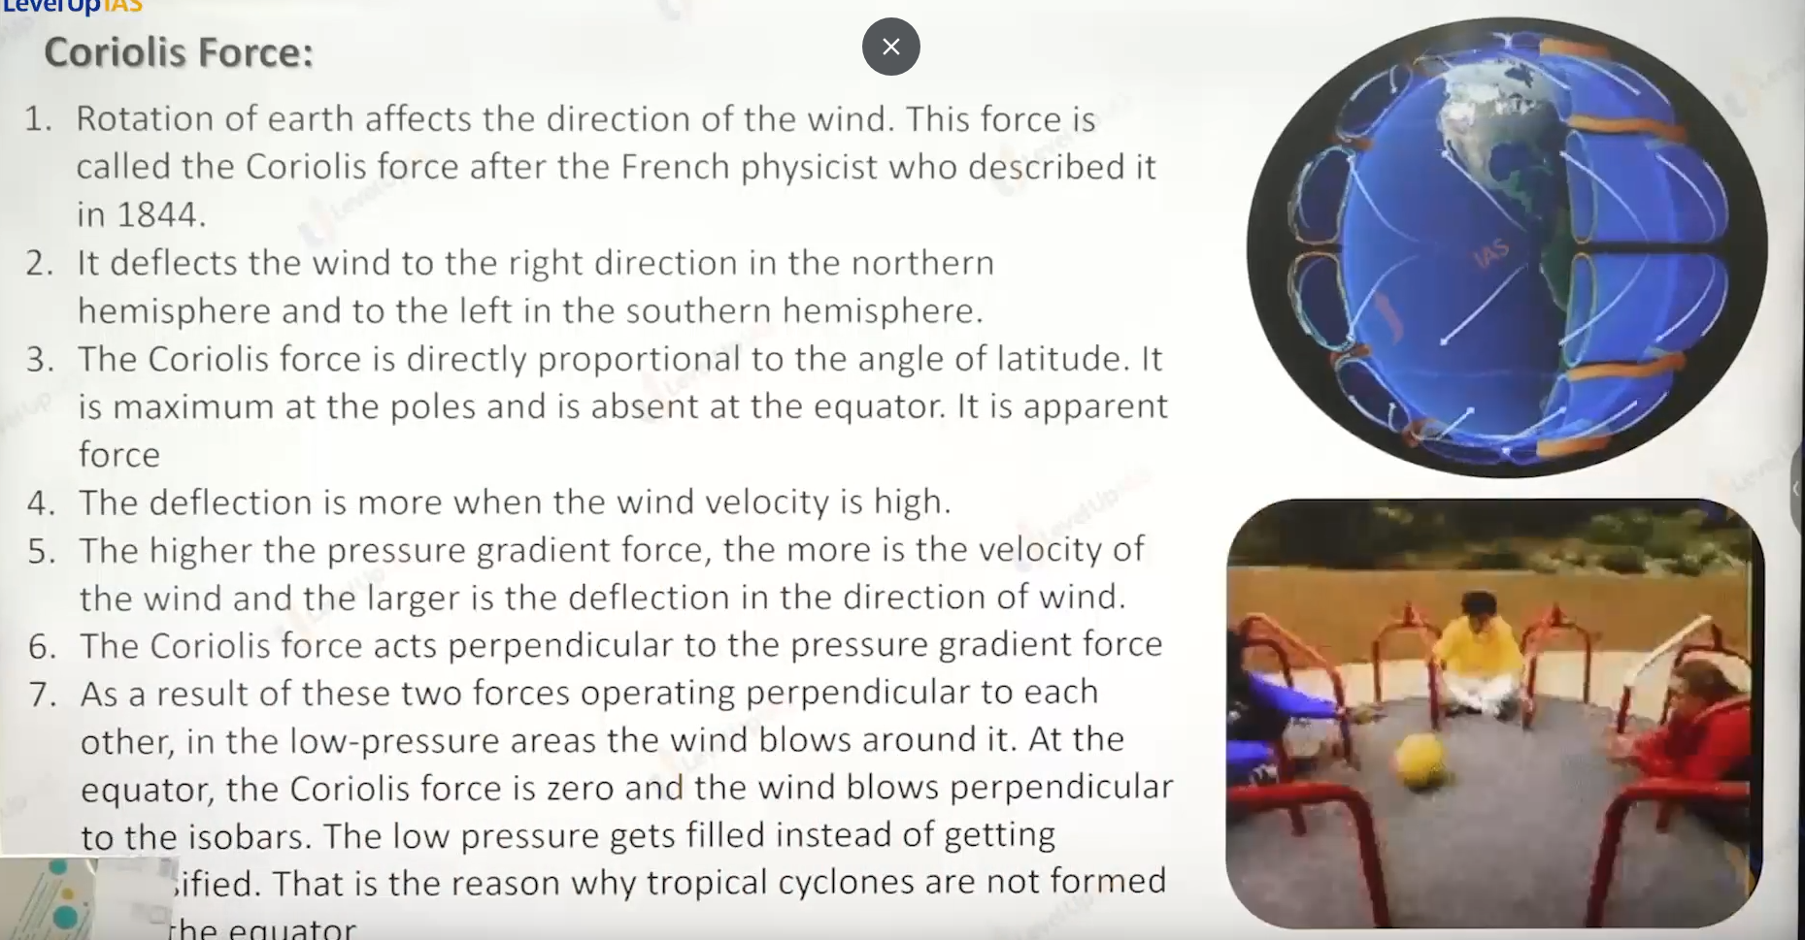

1. FRICTIONAL FORCE:
   1. Frictional force affects the speed of winds. It retards / reduces the speed of winds
   2. Frictional force is greater at the surface and influence of frictional force is generally 1 to 3 km.
   3. Over the sea surface the frictional is minimums and therefore the there fore speed of winds is maximum in water.
2. Type of winds:
3. 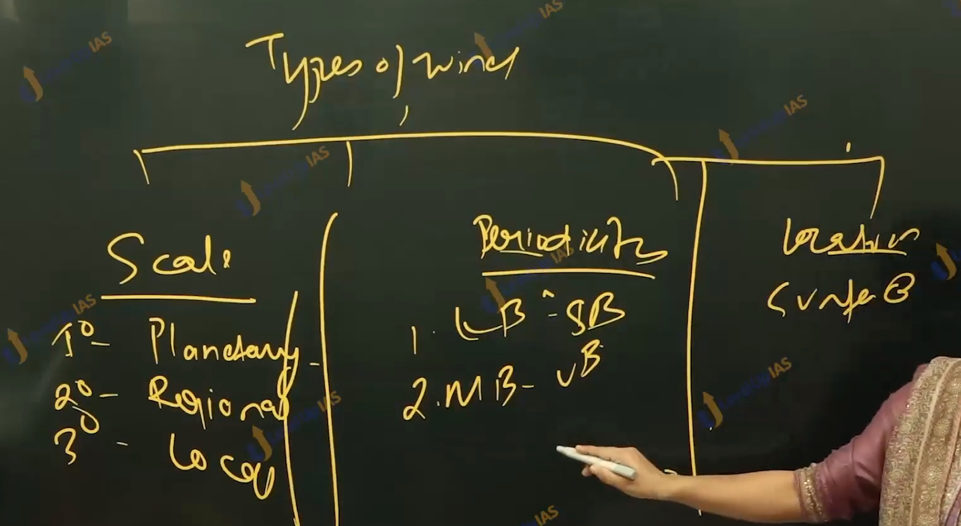

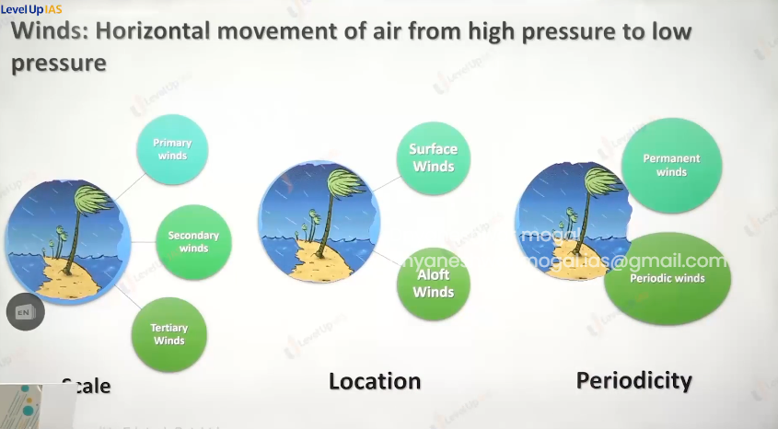

Type of winds :

1. On basis of scale
   1. Primary winds
   2. Secondary winds
   3. Tertiary winds
2. Based on location
   1. Surface winds
   2. Aloft winds
3. On basis of periodicity
   1. Permanent winds
   2. Periodic winds

